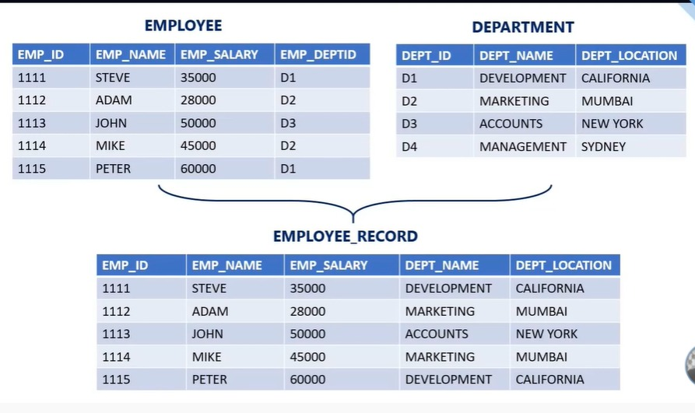

create table employee

(

emp_id char(10),

emp_name varchar(20),

emp_salary char (10),

emp_deptid char(20)

);

insert into employee values(1112,'ADAM','28000','D2'),

(1113,'JHON','50000','D3'),

(1114,'MIKE','45000','D2'),

(1115,'PETER','60000','D5');

select * from employee

update employee set emp_deptid='D1' where emp_id='1115'

create table department

(

dept_id char(10),

dept_name varchar(30),

dept_location varchar(50)

);

insert into department values('D1','DEVELOPMENT','COLIFORNIYA'),

('D2','MARKETING','MUMBAI'),

('D3','ACCOUNT','NEWYORK'),

('D4','MANAGEMENT','SEDNEY');

select e.emp_id,e.emp_name,e.emp_salary,d.dept_name,d.dept_location from employee e inner join department d on e.emp_deptid=d.dept_id